**Simplilearn-_Phase_-2_-project-_FSJD-_ FlyAway**

**Input/output Screens**

**Search flights page**

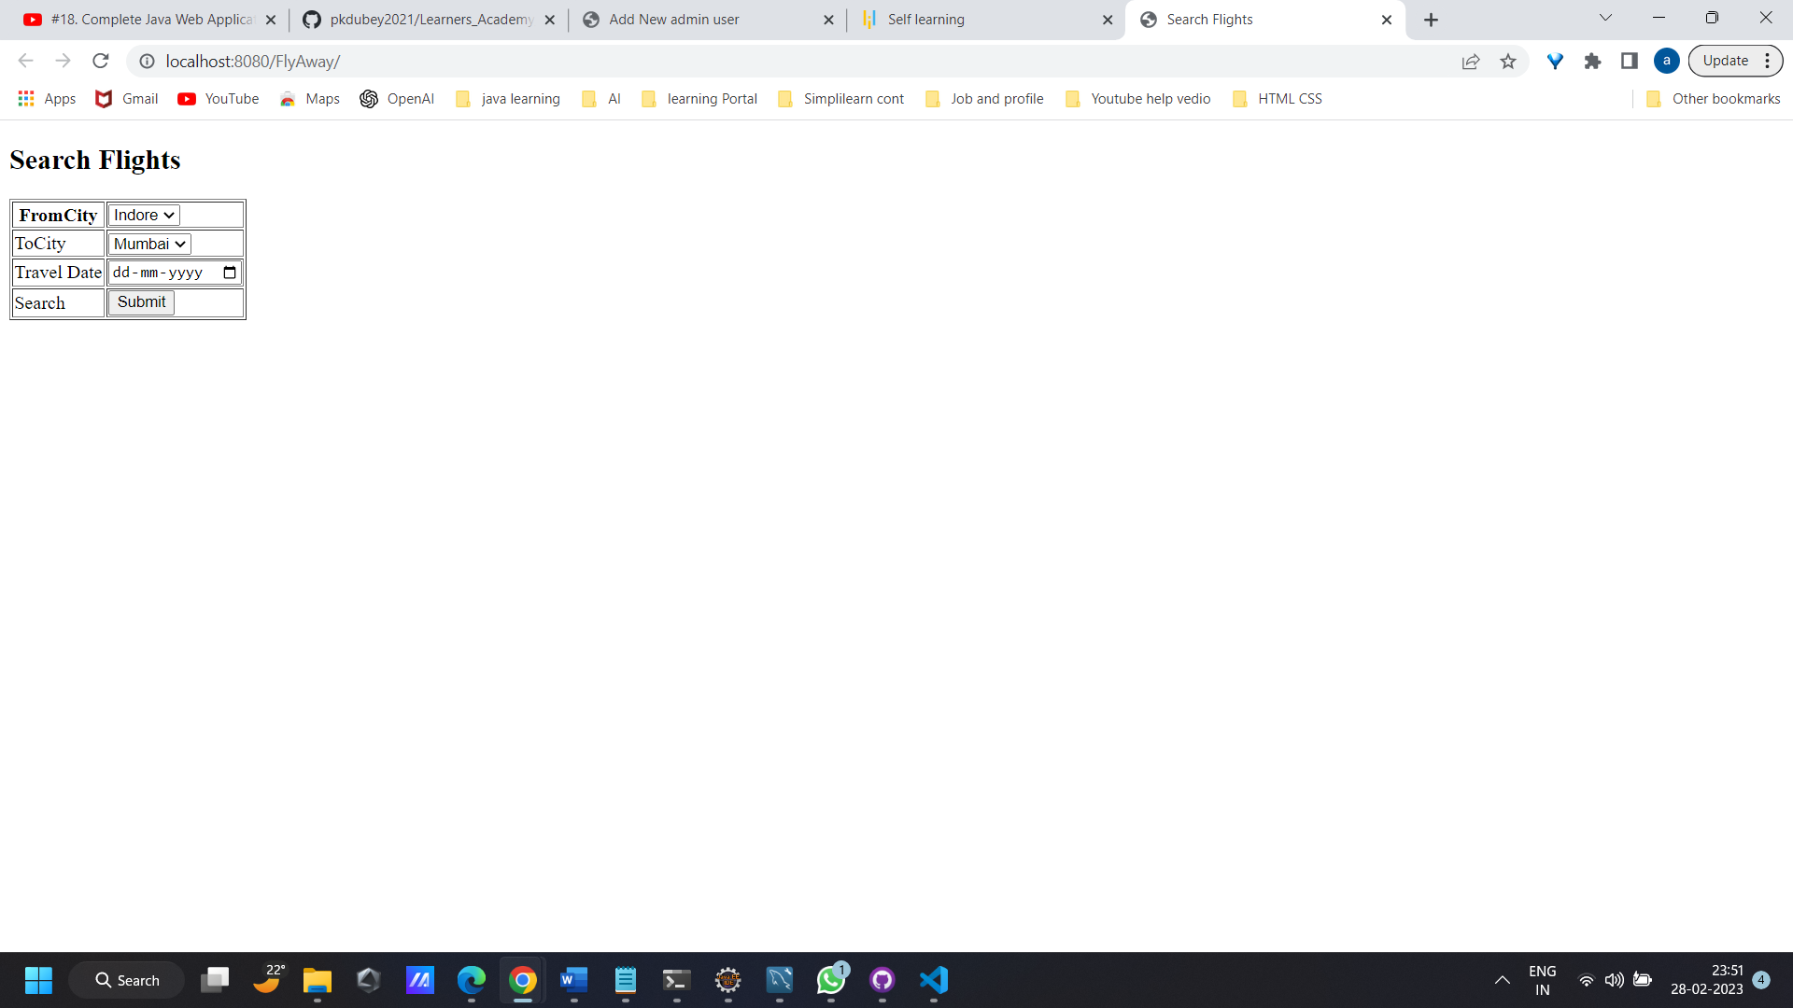

**Admin Login Page**

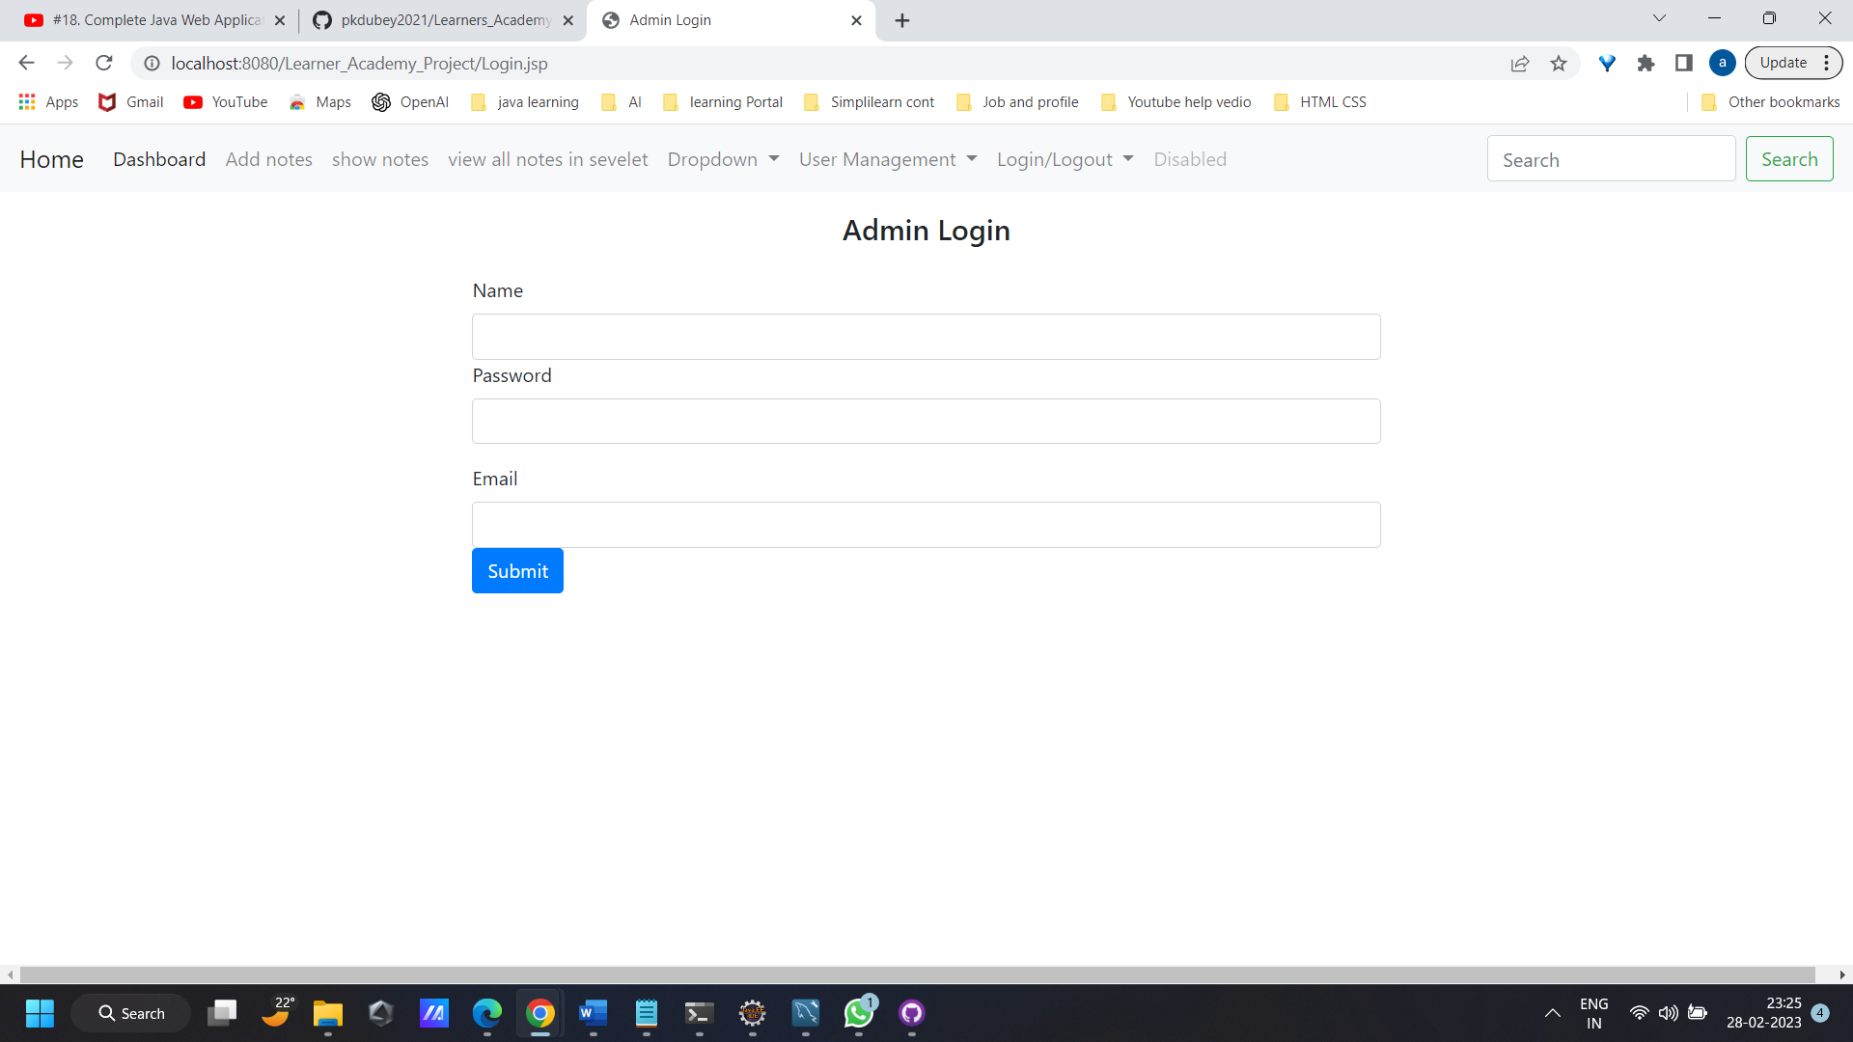

**Add /Manage user users**

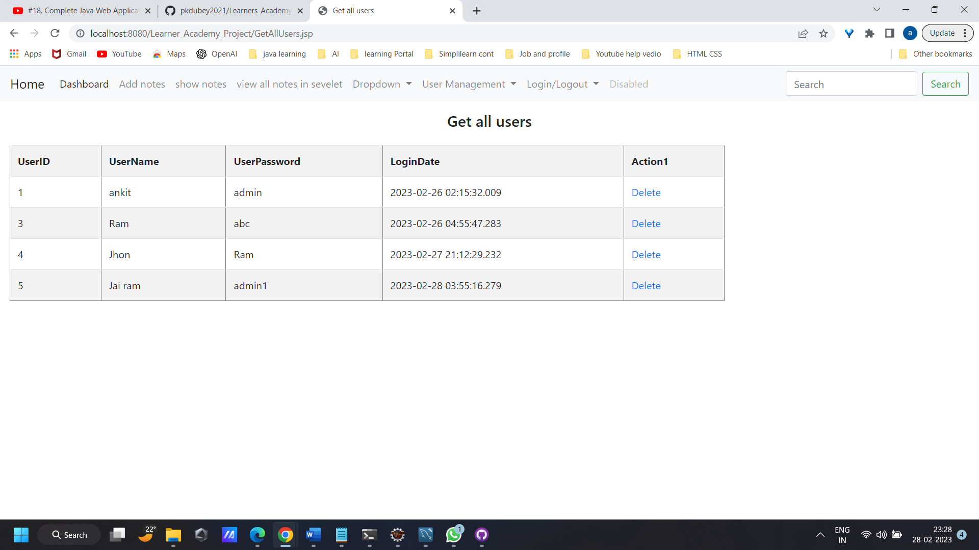

**Add new use**

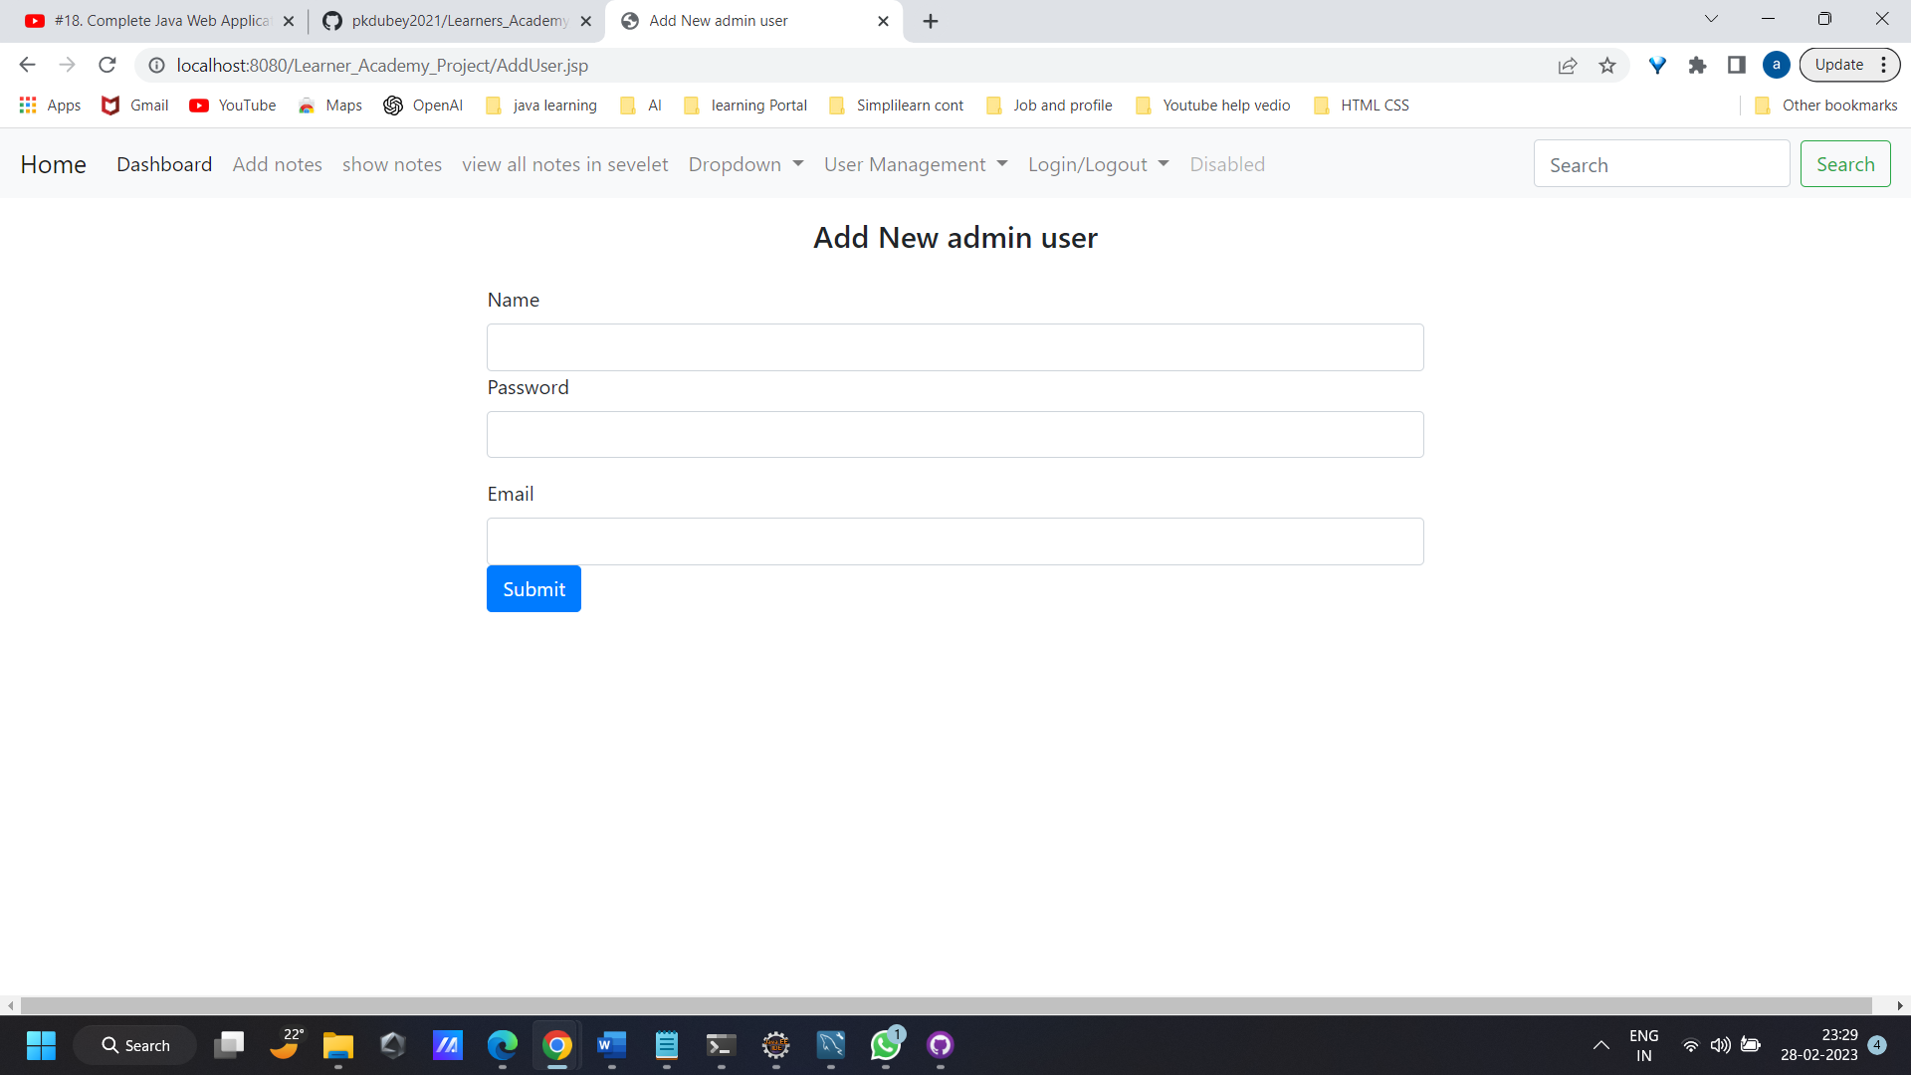

**AddFlight**

